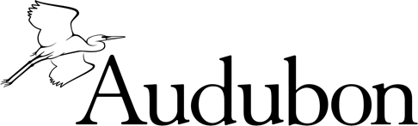
National Audubon Society
Legacy Confirmation Form - Confidential

Welcome to the Grinnell Legacy Society - our way of recognizing friends like you who have provided for the future of birds and their habitat through an estate gift to Audubon. Membership in the Grinnell Legacy Society involves no dues or obligations. It simply allows us to thank you and, with your permission, to recognize you for the plans you have made.

How would you like to be listed in our Annual Report?
Please list my name as: .
My gift is in honor of in memory of .
I prefer to remain anonymous.

Name & Address:

Preferred method of contact:
Telephone: Email

Birthdate(s):

Which benefits of Grinnell Legacy Society membership would you like to receive?
Annual Report
Audubon Engagement Calendar
Invitations to events and trips

I have included in my estate plan a donation of approximately _______ ($ or % of estate) for the further benefit of
Programs of Audubon Rockies
Unrestricted to National Audubon Society
50% Audubon Rockies, 50% NAS

Type of Provision
Outright gift from my will or living trust
Retirement plan
Real estate and/or personal property
Life insurance policy
Other:

Please return this form to: Shari Kolding, Director of Gift Planning, Audubon, 225 Varick Street, 7th Floor, New York, NY 10014. Or via email to skolding@audubon.org

